**National University of Computer and Emerging Sciences**



**Lab Manual 11**

**Object Oriented Programming**

|  |  |
| --- | --- |
| Course Instructor | Mr. Waqas Manzoor |
| Lab Instructor (s) | Mr. Dilawar Shabbir |
| Section | BSE-2C |
| Semester | Spring 2022 |

Department of Computer Science

FAST-NU, Lahore, Pakistan

**Lab Manual – Abstract classes**

**Task 01**

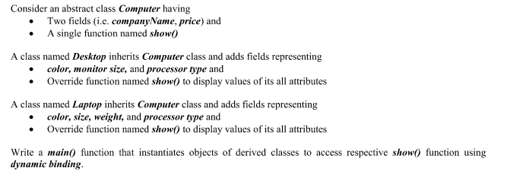

**Task 02**

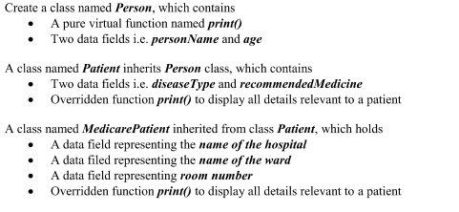



`````````````````````````````````````````````` The End ````````````````````````````````````````````````````````````````